# BCIT

**Comp 4952 HCI for Application Development**

**Technical Programming Option**

# Option Head Mirela Gutica

**Fall 2022**

Mark: ________ /100

Lab 3 ASP.NET MVC

This is an individual **project**. **No late assignments will be accepted**.

**This assignments has 3 parts:**

1. **Part 1:** Read Chapter 1-2 in the textbook, the PP presentation and the documentation content at the links provided in the PP presentation **Module 2 ASP.NET Entity Framework MVC Core MVC 2022**
2. **Part 2:** Read the **Overview of an ASP.NET Core MVC Application** (see below).
3. **Part 3:** Implement the Investment calculator by following the instructions in **Implement a Single Page Application using ASP.NET Core MVC** document.

**Overview of an ASP.NET Core MVC Application**

* + - 1. Select Create a New Project
      2. Select ASP.NET Core Web Application
      3. Specify the project name and the folder
      4. Click Create
      5. Select the template Web application (Model-View-Controller) (you can also select the Empty template and create all folders)
      6. Run the web application and notice the basic functionality.
      7. If you select the MVC template, you will notice 3 important folders: Controllers, Models and Views. You can delete the content of these folders and create your own content, or you can edit them.

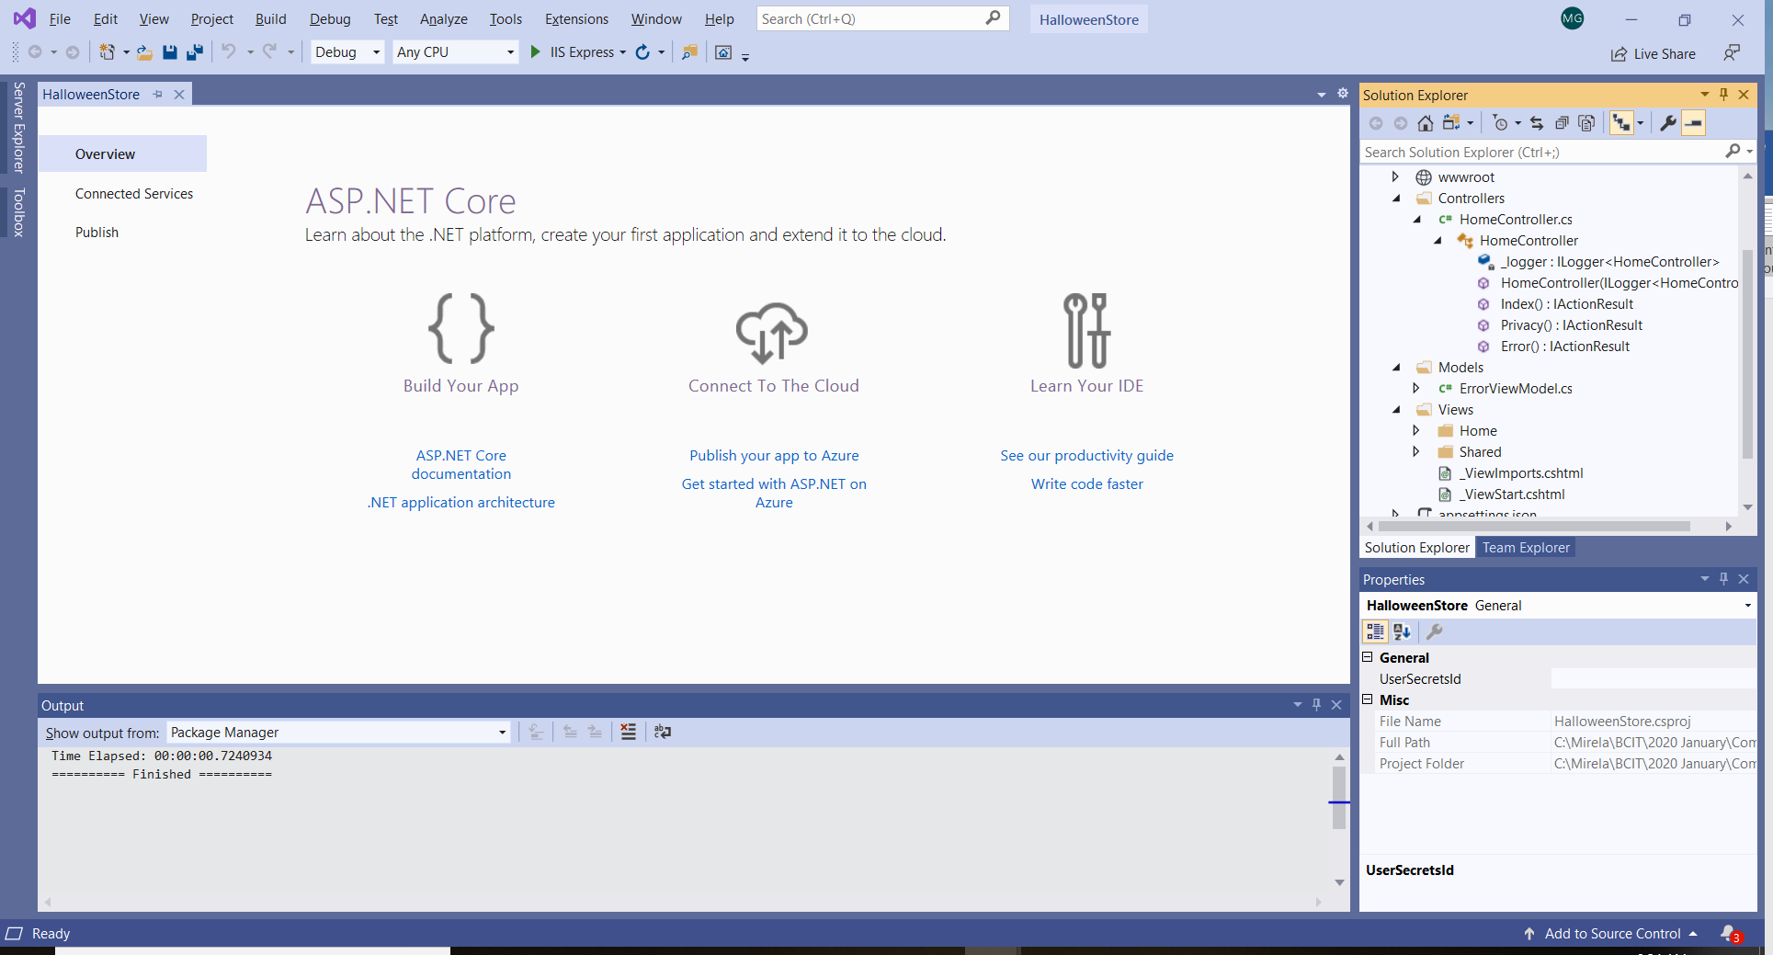

* + - 1. A **controller** interprets the user input.
      2. Controller methods that respond to HTTP GET() and POST() requests are called “action methods” or “actions”. Examples are the Index(), Privacy() and Error() method. All methods return Views more precisely ViewResult objects (of type IActionResult) that display the desired content.
         1. The ViewResult returned from the Index() action will be displayed in the Views/Home/Index.cshtml file. This is the entry point of the web application.
         2. The ViewResult returned from the Privacy() action will be displayed in the Views/Home/Privacy.cshtml file.

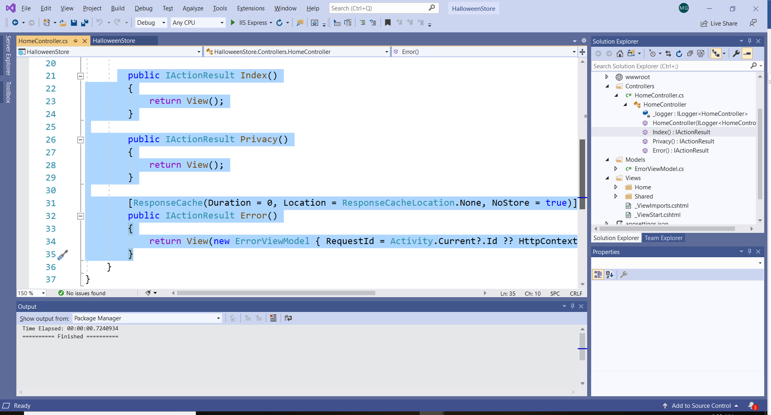

1. The ViewBag property is automatically available to controllers and to views. It is used to return something to the View.
2. Use the ViewBag property to display something in the Vie Example: the privacy message will be displayed in the Privacy.cshtml.

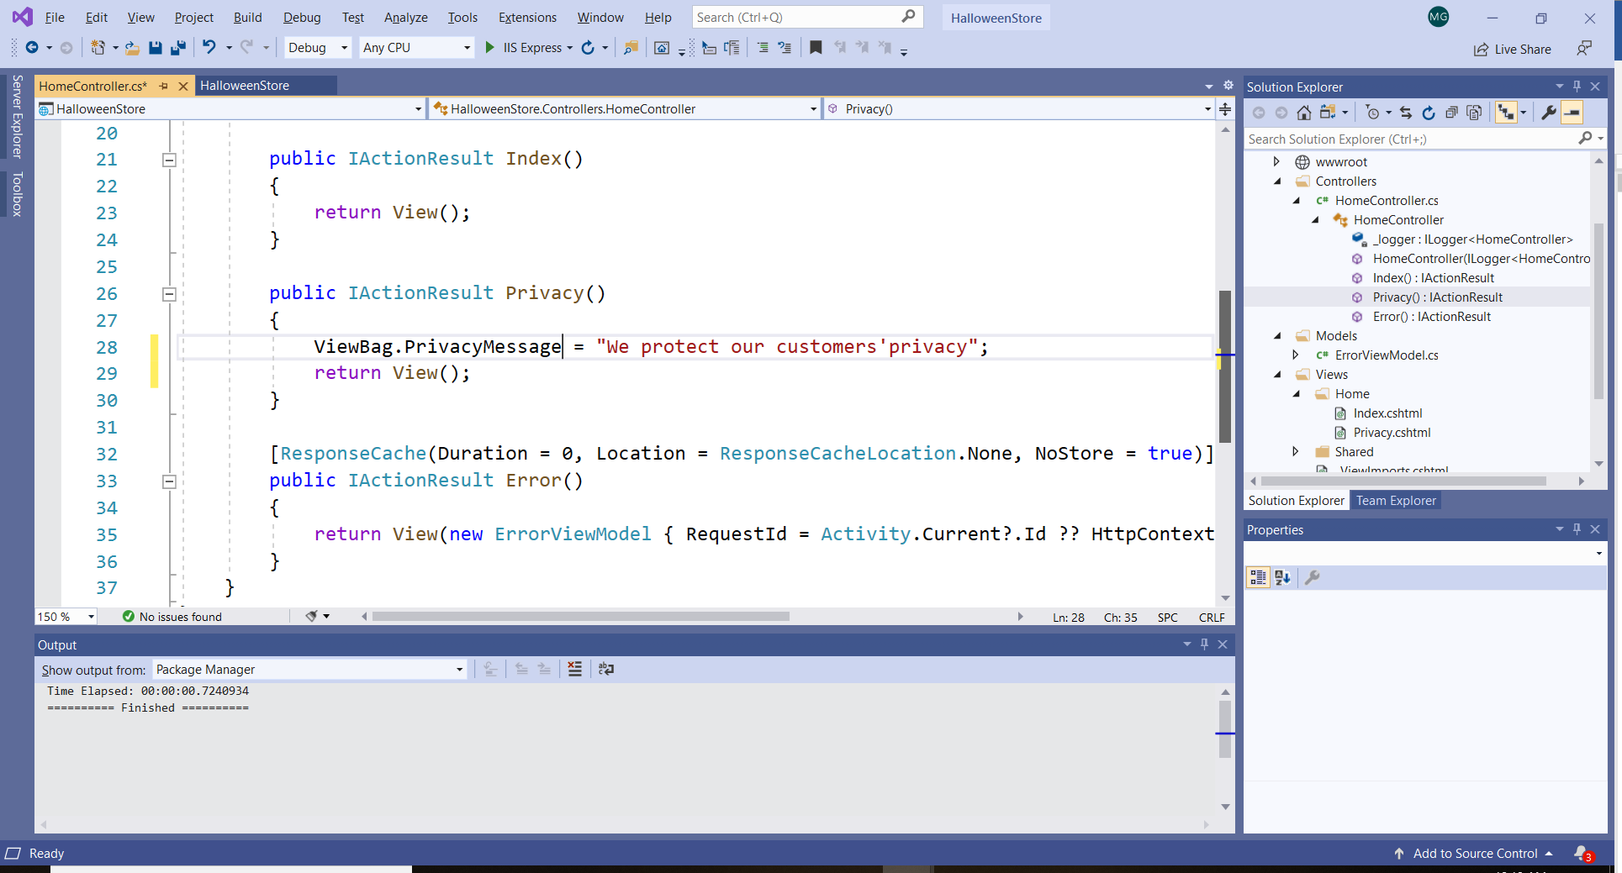

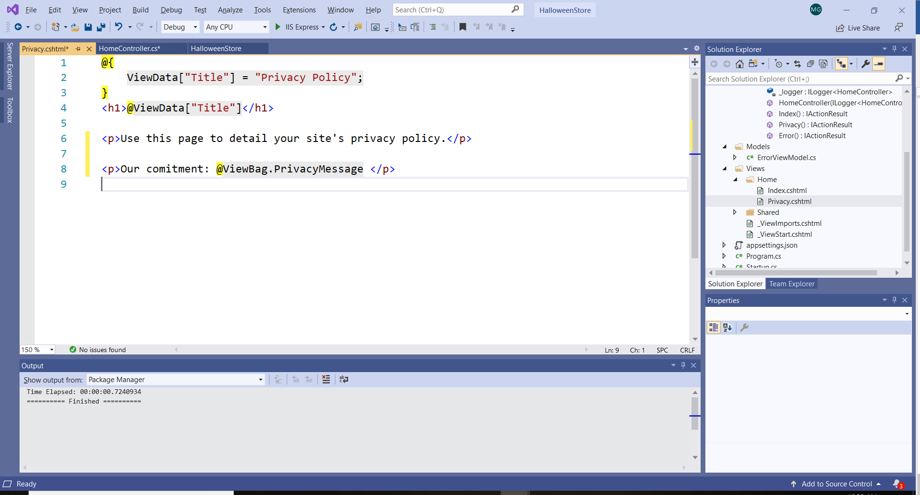

Adding a **model**:

1. Add a model class: right click on the Model folder, select Add / New item, and add a class with the name of your choice:

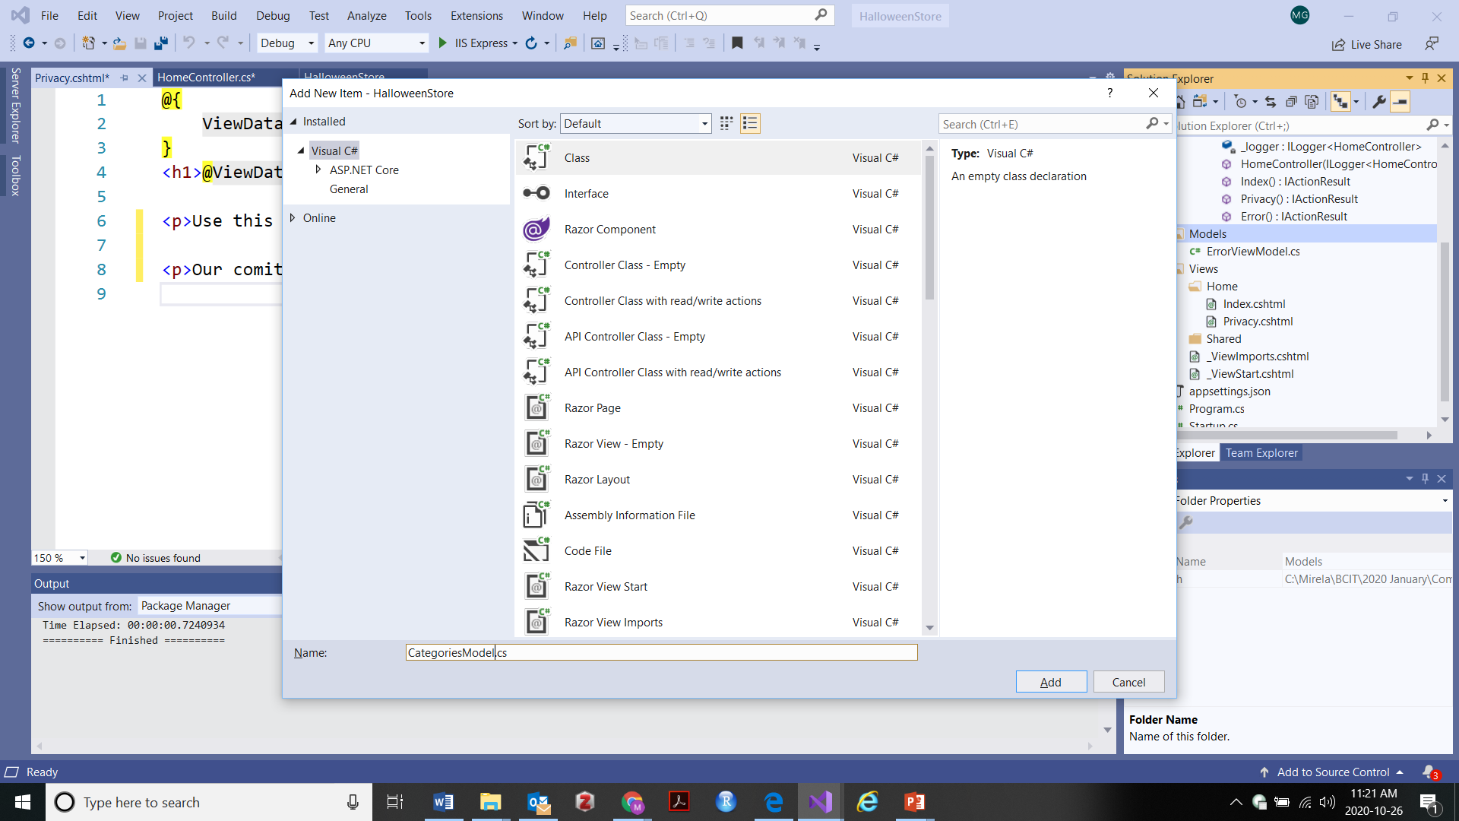

1. Write the logic of your application in the model classes.

The Startup.cs file.

1. The Startup.cs file is very important for your application.
   1. The Configure method is set up for the development environment (env.IsDevelopmet)
   2. The app.UseEndpoints method indicates the entry point in the web application "{controller=Home}/{action=Index}/{id?}");